# 1. spring-rest-handson

**Hands on 1**

**Create a Spring Web Project using Maven**   
Follow steps below to create a project:

1. Go to <https://start.spring.io/>
2. Change Group as “com.cognizant”
3. Change Artifact Id as “spring-learn”
4. Select Spring Boot DevTools and Spring Web
5. Create and download the project as zip
6. Extract the zip in root folder to Eclipse Workspace
7. Build the project using ‘mvn clean package -Dhttp.proxyHost=proxy.cognizant.com -Dhttp.proxyPort=6050 -Dhttps.proxyHost=proxy.cognizant.com -Dhttps.proxyPort=6050 -Dhttp.proxyUser=123456’ command in command line
8. Import the project in Eclipse "File > Import > Maven > Existing Maven Projects > Click Browse and select extracted folder > Finish"
9. Include logs to verify if main() method of SpringLearnApplication.
10. Run the SpringLearnApplication class.

**SOLUTION**

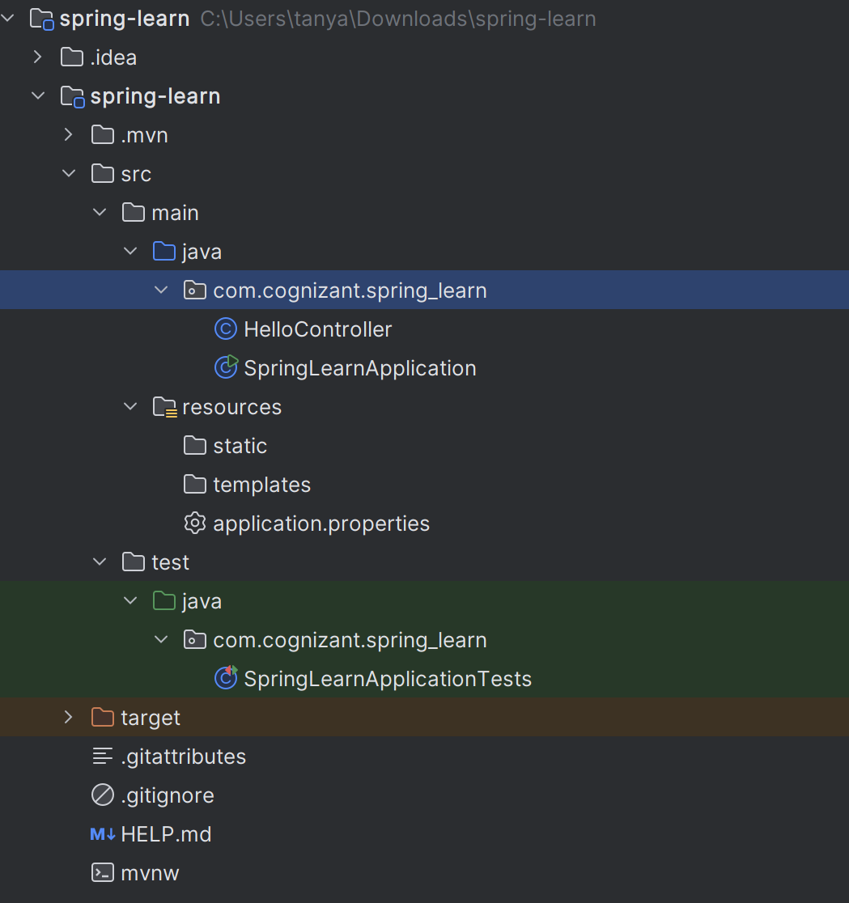

src/main/java/com/cognizant/springlearn/SpringLearnApplication.java

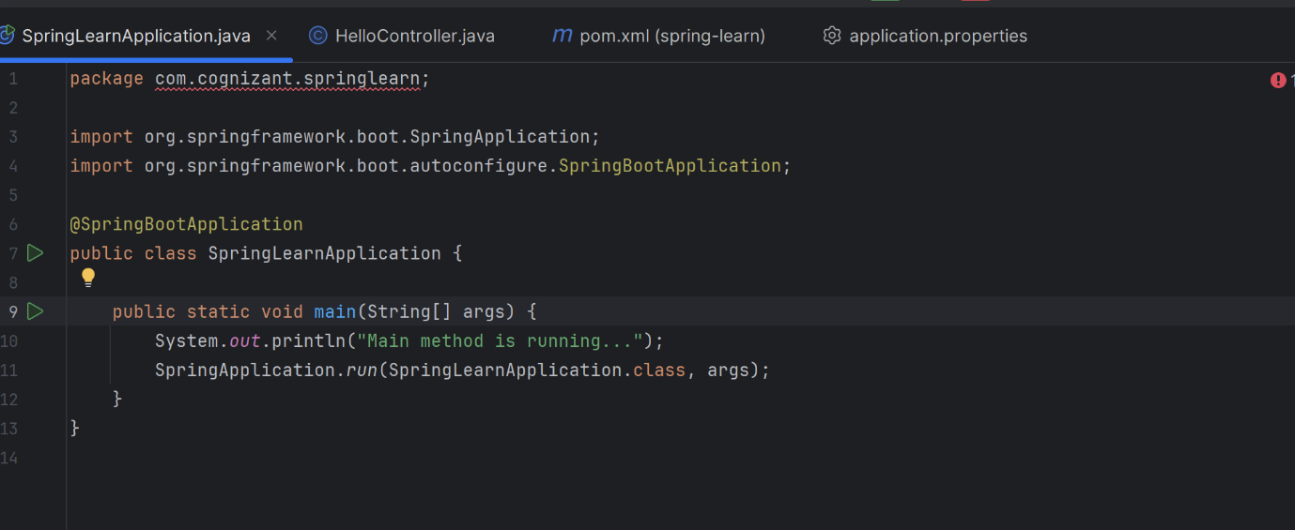

src/main/java/com/cognizant/springlearn

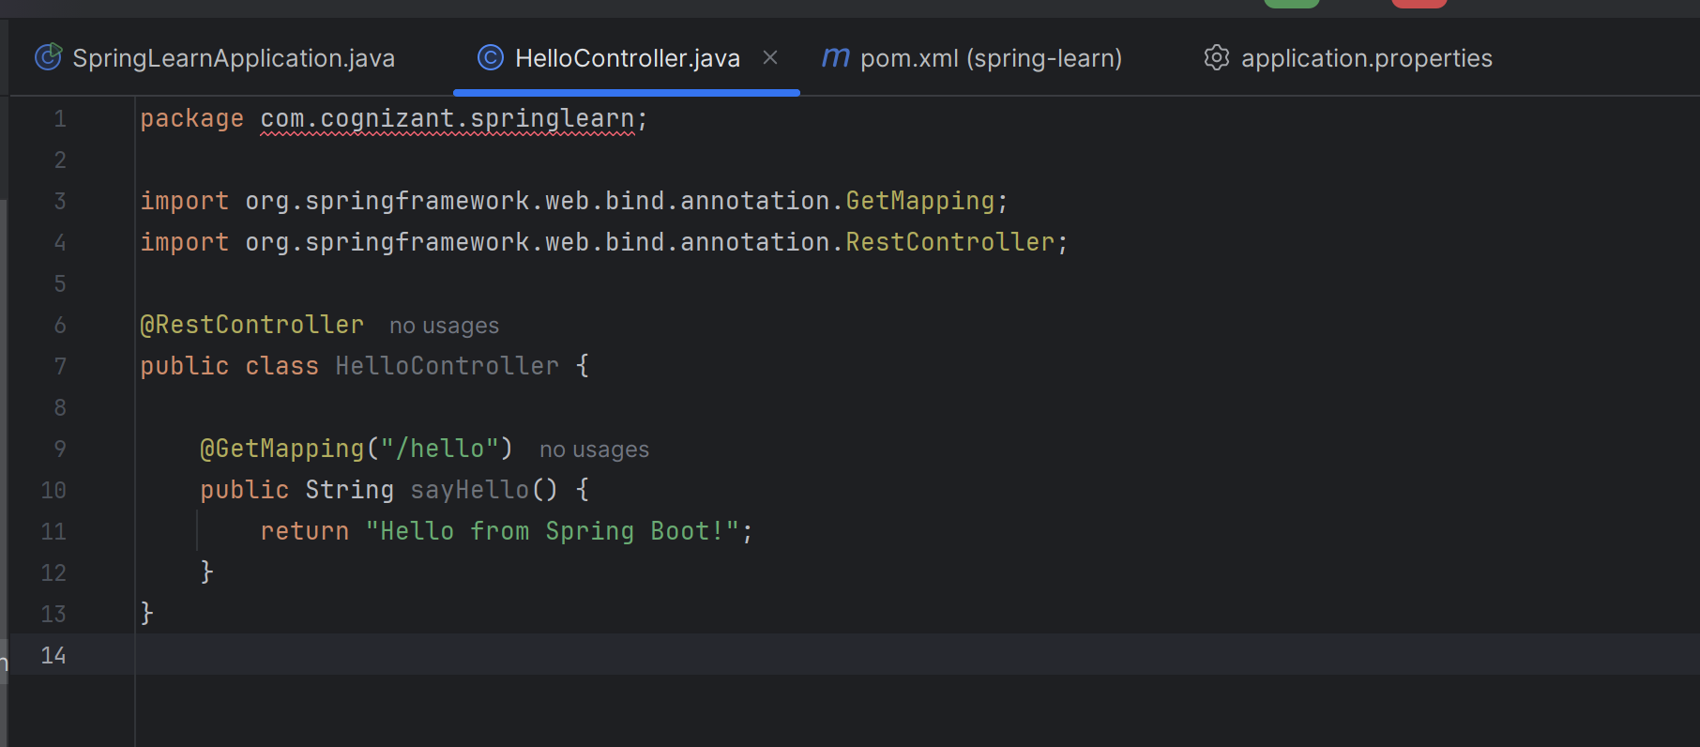

src/main/resources/application.properties

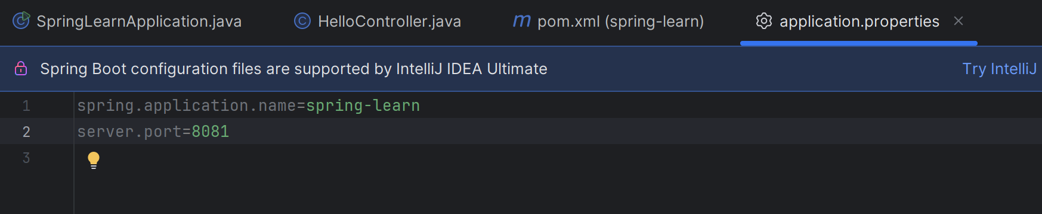

**OUTPUT**

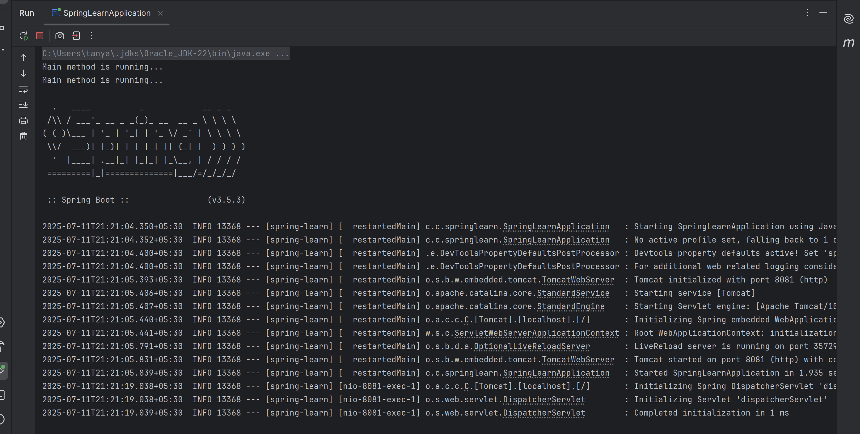

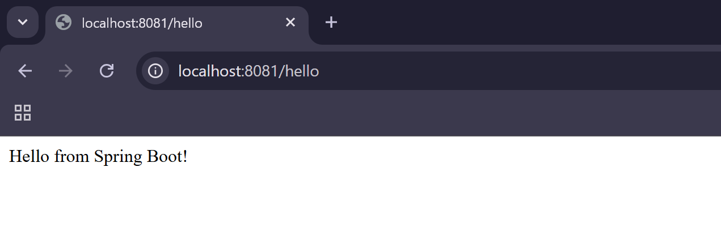

=========================

**Hands on 4**

**Spring Core – Load Country from Spring Configuration XML**   
  
An airlines website is going to support booking on four countries. There will be a drop down on the home page of this website to select the respective country. It is also important to store the two-character ISO code of each country.

|  |  |
| --- | --- |
| **Code** | **Name** |
| US | United States |
| DE | Germany |
| IN | India |
| JP | Japan |

Above data has to be stored in spring configuration file. Write a program to read this configuration file and display the details.

**SOLUTION**

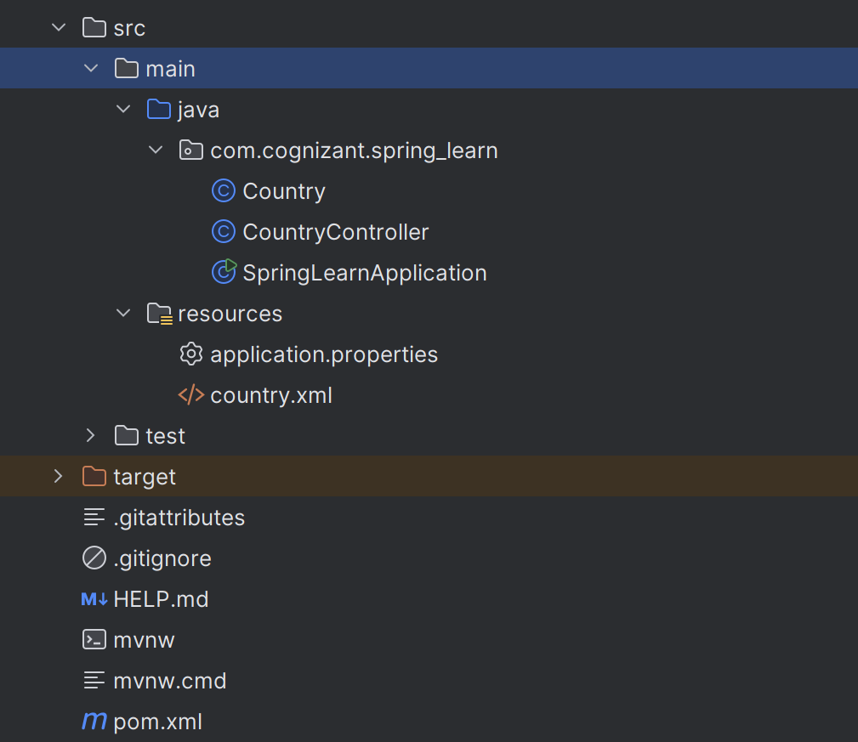

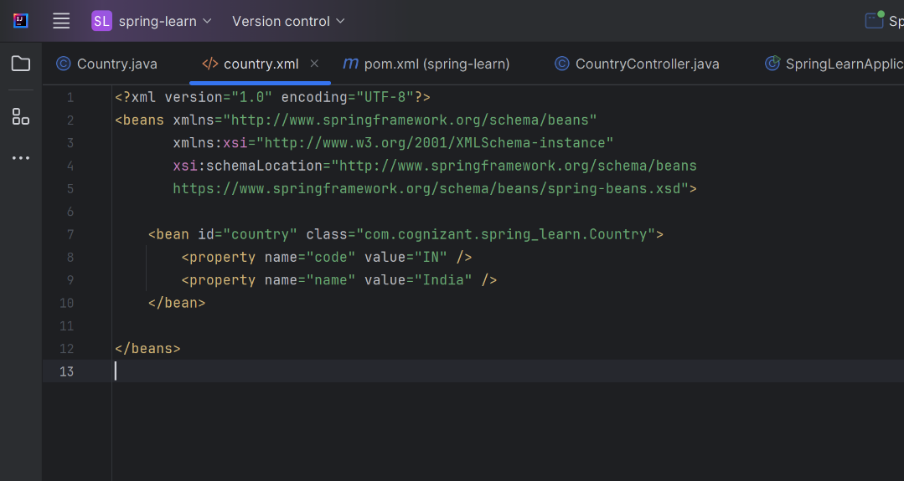

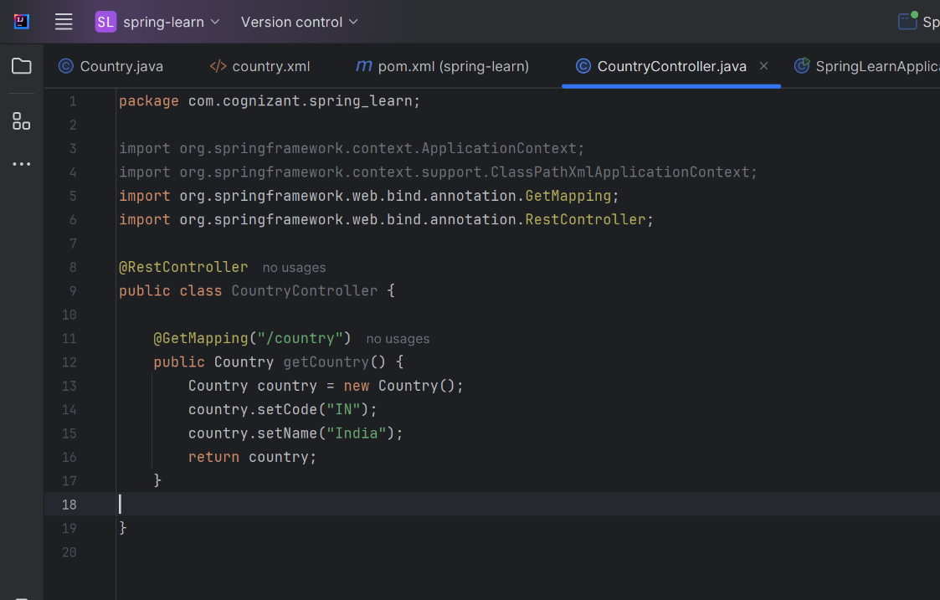

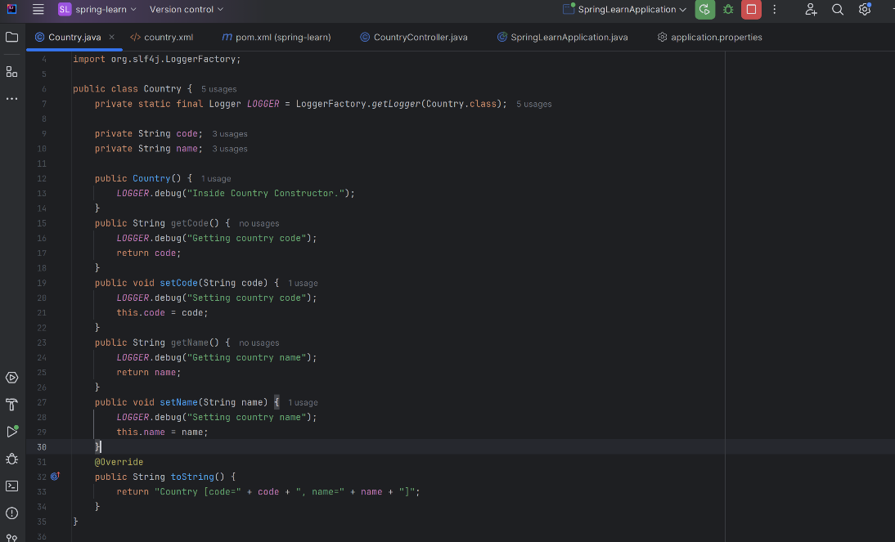

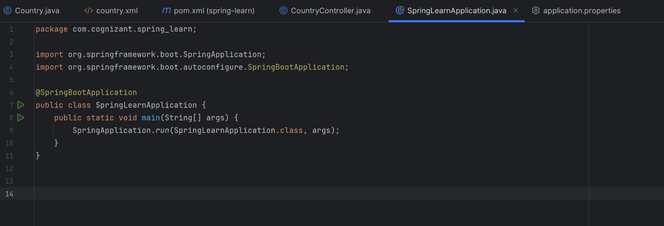

**OUTPUT**

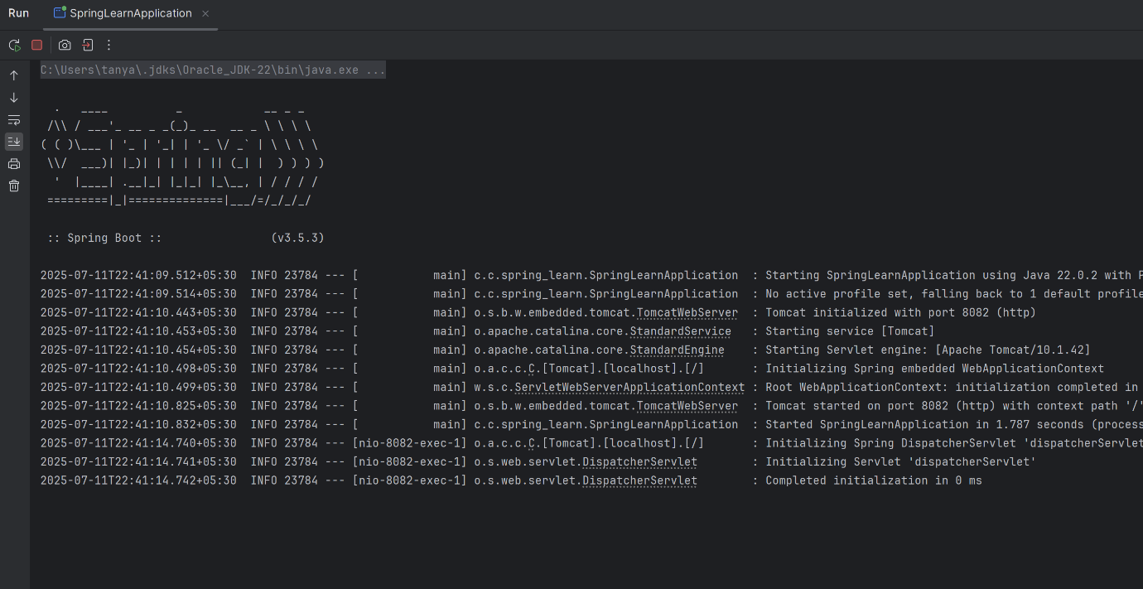

**LOCALHOST**



